**Data Entry Automation of DMG Dispatch Slip**

***Documentation for User of This Mini App***

**1. Pre-requirements**

i. Node js

ii. Zip file of “DE Auto App”

**i. Node js**

Download & Install Node js from Official website.

Download Link: <https://nodejs.org/en>

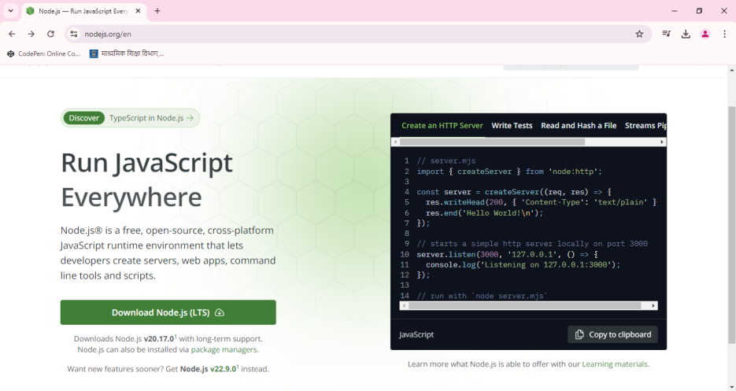

Click on Download Node js (LTD) button to Downlaod installation setup.

After Completion install node js and wait to complete installation & restart.

**ii. Zip file of “DE Auto App”**

To Download this file you must have authentication from Super-Wiser or in-charge.

After Downloading just unzip the file and you are ready to use it.

**2. How to Use it**

As it is Automation so user just have to

1. Provide input file ( i.e. data.xlsx )

2. Click on start.bat file

3. Fill credentials on SSO when asked for.

4. Wait and watch for completion.

**3. Cautions**

* Close all Opened chrome instance before starting the script, Also don’t open any chrome instance while running the script.
* Never Change the Header row of data.xlsx file, just copy paste the data to automate over.
* Do not interrupt Automation if you think there is any error or bug just close the command prompt (/app) then go for bug or error.